Chapter 18, Problem 2.

Using Fig. 18.27, design a problem to help other students better understand the Fouier transform given a wave shape.
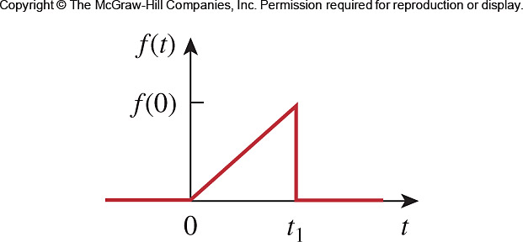

Figure 18.27
For Prob. 18.2.

